24.54: 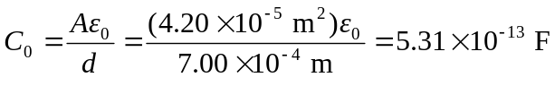
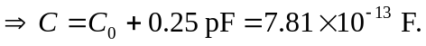
But 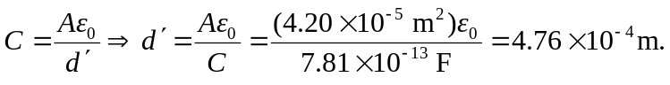
Therefore the key must be depressed by a distance of:

